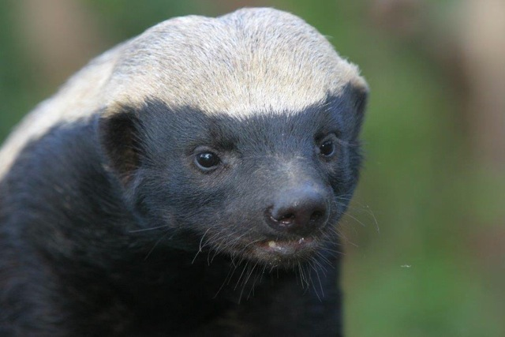
Stoffel
the HoneyBadger
~ Design, Structure and content
I plan to make a simple and informative design with an image of Stoffel being the first thing you see on the homepage

~ Meet the needs of your audience not yourself
Needs of my audience are to be educated on Stoffel and what he means to the South African people, I plan to fulfill this by creating an entertaining yet informative site with lots of easily digestible information

~ Potential domain names
stoffel-tribute.co.za
stoffelthehoneybadger.co.za

~ Key phrases and SEO
I plan on using key phrases that are strongly connected to wildlife conservation and eco tourism as well as general common honey badger

~ Familiarise yourself with your competitors

~ Brief explanation on why you are creating the site
I feel that Stoffel is a great representation of grit and a never give up attitude which is a perfect icon for a South African hero

~ Plan for the site to change overtime
I will be linking an active Stoffel Facebook profile and some HoneyBadger related #’s

~ Outline of the design process

